**Tentative Format for History Sources**

**Name of the Department/Section/School: DEPRATMENT OF ELECTRICAL ENGINEEING**

|  |  |  |  |  |  |  |  |
| --- | --- | --- | --- | --- | --- | --- | --- |
| **Time and Source (When was the department/section/**  **school etc. created?)**  **Who created the department/section/**  **school?**  **For what purpose or audience was department/section/**  **school produced? (Since1921 or year of establishment)** | **Please describe in terms of following with enclosure(s) at separate pages if any:** | | | | | | |
| **Newspaper/Articles/Letters/Diaries/Autobiographies/Oral histories/Literary works/or Writings/Laws/Books/Pamphlets** | **Statistics/Government/Reports/Legislative/Documents/Court Records/Transactions of an Association/annual Reports and financial Records/or Reports of Non-Governmental Organizations.** | **FDP/Seminar/Conferences workshops and other events organized by faculty members/students** | **UG/PG/Ph.D. Degrees awarded** | **Major achievement (s)/turning point(s) etc.** | **Name of the Head/Dean/Section Incharge** | **Remarks (If any)** |
| **(Annexure-I)** | Nil | Nil | **(Annexure-II)** | Data Should be taken from CoE/DAA | 01 patent in  2017 | **(Annexure-IV)** |  |

**(Annexure-I)**

**DEPRATMENT OF ELECTRICAL ENGINEEING**

**(ESTABLISHED 1964)**

**H.B.T.U. KANPUR**

The Department of Electrical Engineering was established in the year 1965. It is one of the oldest and premier engineering department of the university. The number of the students having completed their under graduate programme has reached the 1500 figure mark. The department has been playing a vital role in producing scientists and engineers of highest possible calibre ever since its inception. Apart from offering a bachelors degree programme in electrical engineering, the department also offers part time master degree programme in power electronics and control discipline and part time and regular doctor of philosophy programmes. The department has an annual intake of 33 students in the under graduate B.Tech. Programme. and 10 in Post Graduate M.Tech. Degree Programme and around 5 in PhD programme. The department has been playing a pioneer role in producing world-class engineers and research scholars.  
  
The department has rich and experienced faculty members with very wide exposure.The department has distinguished faculty, all holding degrees from renowned institutes / universities. The faculty member(s) of this department has / have applied for patents, authored good number of books and guided good number of M. Tech. theses, Ph.D. theses. The commitment and dedication, punctuality, experience, expertise and enriched knowledge of the faculty members are few among many the distinguishing features of this department.  
  
The passed out students have proved their mettle in various private and government organisations, public sector organisations, civil services, teaching & research, research & development and multi-national companies. Electrical Engineers rolling out of the institute are well groomed in the core areas of Advanced Control Systems / Power Electronics / Electrical Machines / Power Systems / Measurement and Instrumentation / Machine Design / Power Generation, Transmission & Distribution as well as Software Development/Handling and R&D work. The continuous updations in the course curriculum polishes the budding electrical engineers, in a way, so as to meet the challenges posed by newer technologies and reach the ever-expanding horizons and evolving challenges of industry.  
  
The infrastructure and laboratory facilities are being upgraded from time to time so as to provide adequate opportunities to students and researchers to learn and carry out technological innovations. Financial support for this purpose if provided by the university and TEQIP World Bank. The department has Library, Basic Electrical Engineering Laboratory, Electrical Machines Laboratory, Power Electronics& Electric Drive Laboratory, Microprocessor & Control Laboratory, Power System Laboratory, Network Laboratory, Electrical Fabrication Laboratory, Simulation Laboratory, RTPESS Lab., Electrical Measurement Laboratory, Electrical Science Laboratory and Instrumentation Laboratory. The department has facilities to support teaching and learning activity The department had planned to add advanced laboratories in the areas of advanced control, machine intelligence and also personality development.  
  
The department is continuously engaged in research and development activities. Several National and State level seminars, Technical Festivals, Faculty Development Programmes, Conferences, Symposiums, Expert Lectures, Workshops, Staff Training Programmes, Short Term Courses etc. are part of its yearly agenda. The department is applying for accreditation by National Board of Accreditation, (NBA). The department also undertakes many research projects sponsored by both the government, industry, civil societies etc..

Major activities:

**DEPRATMENT OF ELECTRICAL ENGINEEING**

**(ESTABLISHED 1964)**

**H.B.T.U. KANPUR**

**DEPARTMENT AT A GLANCE**

|  |  |  |  |
| --- | --- | --- | --- |
| **Sl. No.** | **COURSES** | **Sl. No.** | **STUDENTACTIVITY** |
| **1** | UNDERGRADUATE : 01 | **9** | RESONANCE : 05 |
| **2** | POSTGRADUATE : 01 | **10** | WORKSHOP : 03 |
| **FACULTY MEMBER** | | **EVENTS ORGANISED** | |
| **3** | SANCTIONED 09, PRESENT 06 | **11** | SEMINAR WORKSHOP : 07 |
| **STAFF** | | **RESEARCH** | |
| **4** | PRESENT 03 OUTSOURCED 03 | **12** | M.TECH : 87 |
| **INFRASTRUCTURE** | | **13** | PHD : 09 |
| **5** | LABORATORY : 12 | **14** | PAPER : 44 |
| **6** | RESEARCH LAB : 01 | **PUBLICATION** | |
| **7** | LIBRARY : 01 | **15** | BOOK AUTHORED : 12 |
| **SOCIETY** | | **16** | BOOKS REVIEWED : 10 |
| **8** | ASSOCIATION OF EE | **17** | INSTRUCTION MANUAL : 08 |

**DEPRATMENT OF ELECTRICAL ENGINEEING**

**(ESTABLISHED 1964)**

**H.B.T.U. KANPUR**

**HEAD OF DEPARTMENT**

**2003 ON WARDS**

|  |  |  |  |
| --- | --- | --- | --- |
| **Sl. No.** | **NAME** | **FROM** | **UP TO** |
| **1** | DR. SHIV NARAIN | 26.08.2003 | 29.02.2004 |
| **2** | PROF. K. A. MISHRA | 29.03.2004 | 04.10.2007 |
| **3** | MR. S. K. MISHRA | 05.10.2007 | 07.10.2010 |
| **4** | MR. J. K. DWIVEDI | 08.10.2010 | 03.05.2011 |
| **5** | MR. S. K. MISHRA | 04.05.2011 | 01.03.2013 |
| **6** | PROF. J. S. P. RAI (DIRECTOR) | 02.03.2013 | 04.05.2013 |
| **7** | PROF. YADUVIR SINGH | 05.05.2013 | 04.05.2016 |
| **8** | PROF. YADUVIR SINGH | 05.05.2016 | 29.05.2016 (FN) |
| **9** | MR. J. K. DWIVEDI | 29.05.2016 (AN) | 11.05.2019 |
| **10** | PROF. YADUVIR SINGH | 22.05.2019 |  |

**DEPRATMENT OF ELECTRICAL ENGINEEING**

**(ESTABLISHED 1964)**

**H.B.T.U. KANPUR**

**VENUE**

|  |  |  |
| --- | --- | --- |
| **Sl. No.** | **LAB** | **ROOM NO.** |
| **1** | ELECTRICAL ENGINEERING LAB | 101 |
| **2** | ELECTRICAL MACHINE LAB | 110 |
| **3** | NETWORK LAB | 101 |
| **4** | ELECTRICAL MEASURMENT LAB | 116 |
| **5** | CONTROL LAB | 116 |
| **6** | POWER SYSTEM LAB | 110 |
| **7** | ELECTRIC DRIVE LAB | 212 |
| **8** | MICROPROCESSOR LAB | 106 |
| **9** | ELECTRICAL SIMULATION LAB | 113 |
| **10** | ELECTRICAL INSTRUMENTATION LAB | 116 |
| **11** | POWER ELECTRONICS LAB | 212 |

**DEPRATMENT OF ELECTRICAL ENGINEEING**

**(ESTABLISHED 1964)**

**H.B.T.U. KANPUR**

**DEPARTMENTAL FACULTY**

|  |  |
| --- | --- |
| **NAME** | **DEGISNATION** |
| DR. YADUVIR SINGH | PROFESSOR & HEAD |
| MR. J. K. DWIVEDI | ASSOC. PROF. |
| MR. C. N. SINGH | ASSOC. PROF. |
| VACANT | ASSOC. PROF. |
| DR. ARCHANA SINGH | ASST. PROF. |
| MR. JAMEEL AHAMAD | ASST. PROF. |
| DR. SANJIV KUMAR | ASST. PROF. |
| VACANT | ASST. PROF. |
| VACANT | ASST. PROF. |
|  |  |
| MR. UDIT KR. SINGH | GF |
| MR. PRASHANT PANDEY | GF |
| **STAFF** | |
| MS. DINU NIRANJAN | RESEARCH ASSTT. |
| MR. BRIJ MOHAN | ATTND. |
| MR. RAJ KISHOR | ATTND. |
| **STAFF OUTSOURCING** | |
| MR. GIRISH AWASTHI | TECHNICAL ASSTT. |
| MR. ABHISHEK DIXIT | INSTRUCTOR |
| MR. AJIT KUMAR | LOWER DEVISON CLEARK |

**Details of EE during headship of Prof. Yaduvir singh**

02 National Conferences,

---------------------------------

2013, 2015

02 National Seminars

----------------------------

2014, 2019

03 FDPs

------------

2014, 2015, 2019

13 Expert talks

--------------------

2013, 2014, 2015, 2019

01 patent

-------------

2017

10 books

------------

2019-2021

13 M.Tech.

----------

07 2013, 03 2015, 03 2020

01 PhD

---------

2021

**(Annexure-II)**

**FDP/Seminar/Conferences workshops and other events organized by faculty members/students**

|  |  |  |
| --- | --- | --- |
| **Sl. No.** | **Title of the FDP/Conference/Seminar/Talk** | **Dates** |
|  | Industrial Talk by AIMIL R&D Head | 19 August 2021 |
|  | Industrial Talk by Mr. Arvind Dixit CEO Advance Technology, India | 16 August 2021 |
|  | One Week Online Faculty Development Programme on “Intelligent Control and Its Applications” | 16-20 August 2021 |
|  | Two Week FDP on "Control & Machine Intelligence" | 16-28 Sept. , 2019 |
|  | National Seminar on "Energy & Earth Intelligence" | 21 Nov. , 2019 |
|  | A one week “Induction Programme For First Year B-Tech. Students” | 15-21 January, 2018 |
|  | Three days workshop on “Management Capacity Enhancement Programme – Incompliance with NBA and NAAC Accreditation” | 29 – 31 March, 2017 |
|  | Three days workshop on “Effective Pedagogy for Engineering Faculties” | 26 – 28 March, 2017 |
|  | FDP on “Simulation Techniques of Power Electronics Converters (STPEC)” | 27 February - 04March, 2017 |
|  | Annual technical fest “Resonance-11” | 10 - 11 March 2011 |
|  | Two days workshop on “Robotics” | 03 - 04 March 2011 |
|  | FDP on “Electric Drive Simulation Using Simulink, A Matlab Tool” | 12 - 17January, 2009 |

**FDP Details**

“Electric Drive Simulation Using Simulink, A Matlab Tool” , (Sponsored by

TEQIP, World Bank), January 12 - 17, 2009

****

|  |  |
| --- | --- |
| **scan0004.png** | **scan0005.png** |
| **scan0006.png** | **scan0008.png** |

|  |  |
| --- | --- |
| **scan0009.png** | **scan0011.png** |
| **scan0010.png** |

|  |  |
| --- | --- |
| **scan0012.png** | **scan0013.png** |
| **scan0014.png** | |

**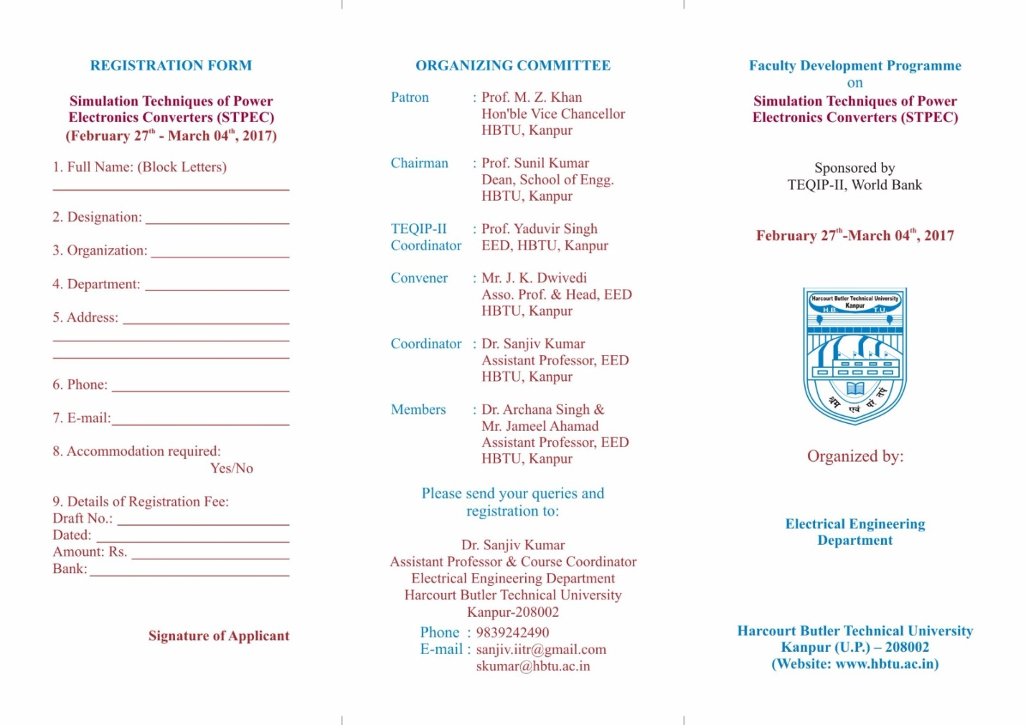**

**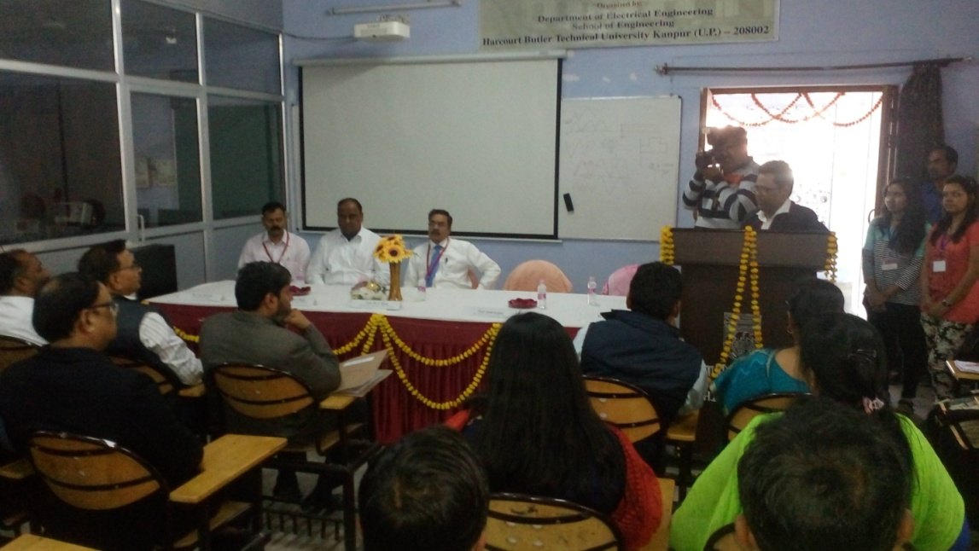**

**Resonance**

**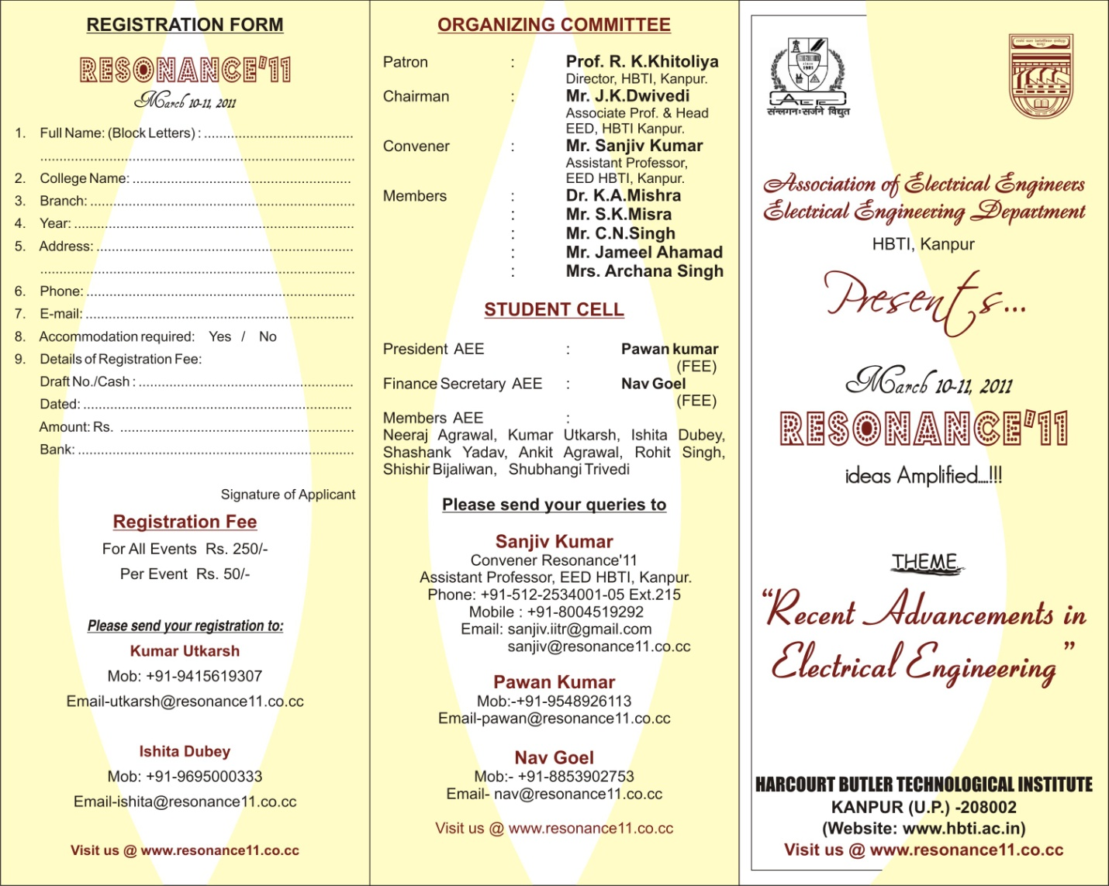**

**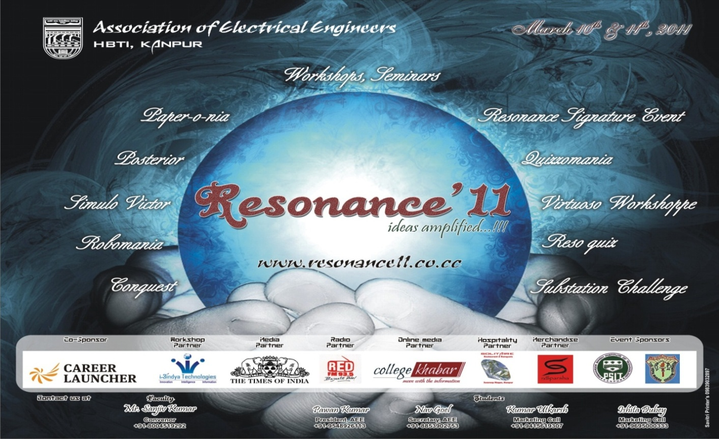**

|  |
| --- |
| **Resa_1.png** |
| **scan0003.png** |

|  |  |
| --- | --- |
| **scan0017.png** | **scan0019.png** |
| **scan0018.png** | **scan0020.png** |

|  |  |
| --- | --- |
| **scan0021.png** | **scan0022.png** |
| **scan0023.png** | **scan0024.png** |

|  |  |
| --- | --- |
| **scan0025.png** | **scan0026.png** |
| **scan0027.png** | |

|  |
| --- |
| **scan0028.png** |
| **scan0029.png** |

|  |  |
| --- | --- |
| **scan0030.png** | **scan0031.png** |

|  |  |
| --- | --- |
| **scan0032.png** | **scan0033.png** |

|  |
| --- |
| **scan0034.png** |
| **scan0035.png** |

|  |
| --- |
| **scan0036.png** |
| **scan0037.png** |
| **scan0038.png** |

**Workshop**

|  |  |
| --- | --- |
| **scan0015.png** | **scan0016.png** |
| **Work_1.png** | |

**(Annexure-III)**

|  |  |  |  |
| --- | --- | --- | --- |
| **Head of Department**  2003 onwards | | | |
| **Sl.No.** | **Name** | **From** | **Up To** |
|  | Dr. Shiv Narain | 26.08.2003 | 29.02.2004 |
|  | Prof. K.A. Mishra | 29.03.2004 | 04.10.2007 |
|  | Mr. S.K. Mishra | 05.10.2007 | 07.10.2010 |
|  | Mr. J.K. Dwivedi | 08.10.2010 | 03.05.2011 |
|  | Mr. S.K. Mishra | 04.05.2011 | 01.03.2013 |
|  | Prof. J.S.P. Rai (Director) | 02.03.2013 | 04.05.2013 |
|  | Prof. Yaduvir Singh | 05.05.2013 | 04.05.2016 |
|  | Prof. Yaduvir Singh | 05.05.2016 | 29.05.2016(FN) |
|  | Mr. J.K. Dwivedi | 29.05.2016 | 11.05.2019 |
|  | Prof. Yaduvir Singh | 22.05.2019 |  |